**Gas Leakage Monitoring and Alerting System**

**Introduction:**

The Internet of things (IoT) is the system of gadgets, vehicles, and home machines that contain hardware, programming, actuators, and network which enables these things to the interface, collaborate and trade information. IoT includes broadening Internet networks past standard devices, for example, work areas, workstations, cell phones and tablets, to any scope of the generally stupid or non-web-empowered physical devices and ordinary articles. Installed with innovation, these gadgets can convey and connect over the Internet, and they can be remotely observed and controlled. The meaning of the Internet of things has advanced because of the union of numerous innovations, ongoing examination, AI, ware sensors, and implanted frameworks. Conventional fields of installed frameworks, remote sensor systems, control frameworks computerization (counting home and building mechanization), and others all add to empowering the Internet of things. A gas spill alludes to a hole of petroleum gas or a different vaporous item from a pipeline or other regulation into any territory where the gas ought not to be available. Since a little hole may steadily develop a hazardous convergence of gas, spills are perilous. Notwithstanding causing flame and blast dangers, holes can slaughter vegetation.

**HARDWARE INFORMATION:**

**1. Arduino Uno:**

Arduino UNO is a microcontroller which is completely based on the ATmega328P Processor. The Arduino UNO consists of 14 digit pins which can be used either for Input or Output. Apart from that it contains 6 analog inputs, a 16 MHz quartz crystal, a USB connection, a power jack, an ICSP header and a reset button. It has 32 KB flash memory, 2 Kb SRAM and 1 KB EEPROM.The Uno differs from all preceding boards in that it does not use the FTDI USB-to-serial driver chip. Instead, it features the Atmega16U2 (Atmega8U2 up to version R2) programmed as a USB-to-serial converter.

**2.LCD (Liquid Crystal Display):**

LCD stands for Liquid Crystal Display. LCD is finding widespread use replacing LEDs (seven segment LEDs or other multi segment LEDs) because of the following reasons:

1. The declining prices of LCDs.

2. The ability to display numbers, characters and graphics. This is in contrast to LEDs, which are limited to numbers and a few characters.

3. Incorporation of a refreshing controller into the LCD, thereby relieving the CPU of the task of refreshing the LCD. In contrast, the LED must be refreshed by the CPU to keep displaying the data.

**3.Buzzer:**

A buzzer or beeper is an audio signaling device, which may be mechanical, electromechanical, or piezoelectric. Typical uses of buzzers and beepers include alarm devices, timers and confirmation of user input such as a mouse click or keystroke. The first electric buzzer was invented in 1831 by Joseph Henry.

**SENSORS**

**LM 35 (temp. sensor) :**

For the sensors, if any fire is to be happened then the temperature sensor will sense an high change(positive change) in temperature and will send an pulse to microcontroller which intern will send an update to the internet through IoT, and as well it will trigger an siren alarm in the RF Rx kit(sub board).

**MQ-2 (Gas Sensor):**

MQ 2 sensor is basically an LPG (liquefied petroleum gas) which is composed of propane & butane, so when a gas leakage is sensed by the sensor it will send an high pulse to the Mc which will update it in the IoT, and even an buzzer is heard in the RF Rx kit. And the problem can be sorted & solved. Thus the overall components & sensors play a role in the paper as explained above.

**LPG sensor:**

It is an ideal sensor to detect the presence of a dangerous LPG leak in our home or in a service station, storage tank environment and even in vehicles which uses LPG gas as its fuel. This unit can be easily incorporated into an alarm circuit/unit, to sound an alarm or provide a visual indication of the LPG concentration. The sensor has excellent sensitivity combined with a quick response time.

**LITERATURE REVIEW**

In the year of 2008, LIU zhen-ya, WANG Zhen-dong and CHEN Rong, “Intelligent Residential Security Alarm and Remote Control System Based On Single Chip Computer”, the paper focuses on, Intelligent residential burglar alarm, emergency alarm, fire alarm, toxic gas leakage remote automatic sound alarm and remote control system, which is based on 89c51 single chip computer. The system can perform an automatic alarm, which calls the police hotline number automatically. It can also be a voice alarm and shows the alarm's address. This intelligent security system can be used to control the electrical power remotely through the telephone. In the year of 2008, Chen Peijiang and Jiang Xuehhua, “Design and implementation of Remote Monitoring System Based on GSM”, this paper focuses on the wireless monitoring system, because the wireless remote monitoring system has more applications a remote monitoring system based on SMS through GSM In the year of 2002, K. Galatsis, W. Wlodarska, K. Kalantar-Zadeh and A. Trinchi,“Investigation of gas sensors for vehicle cabin air quality monitoring”, this paper focuses on, car cabin air quality monitoring can be effectively analyzed using metal oxide semiconducting (MOS) gas sensors. In this paper, commercially available gas sensors are compared with fabricated MQ3 based sensors that possess comparable gas sensing properties. The sensor has a response 74% higher relative to the best commercial sensor tested.

**Smart Gas Level Monitoring, Booking & Gas Leakage Detector** over IoT This project proposed the most common problem experienced in our day- to- day lives that is regarding GAS containers going empty. We bring this paper to create awareness about the reducing weight of the gas in the container, and to place a gas order using IOT. The gas booking/order is being done with the help of IOT and that the continuous weight measurement is done using a load cell which is interfaced with a Microcontroller (to compare with an ideal value). For ease it is even has been added with an RF TX & Rx modules which will give the same information. When it comes to the security of the kit as well as the gas container we have an MQ-2(gas sensor), LM 35(temperature sensor), which will detect the surrounding environment for any chance of error. Whenever any change is subjected in any of the sensors (load cell, LM35, Mq-2) a siren (60db) is triggered. A. LM 35 (temp. sensor) For the sensors, if any fire is to be happened then the temperature sensor will sense an high change(positive change) in temperature and will send an pulse to microcontroller which intern will send an update to the internet through IoT, and as well it will trigger an siren alarm in the RF Rx kit(sub board). B. MQ-2 (Gas Sensor) MQ 2 sensor is basically an LPG (liquefied petroleum gas) which is composed of propane & butane, so when a gas leakage is sensed by the sensor it will send an high pulse to the Mc which will update it in the IoT, and even an buzzer is heard in the RF Rx kit. And the problem can be sorted & solved. Thus the overall components & sensors play role in the paper as explained above.

**Gas Leak Detection and Localization System through Wireless Sensor Networks**

In this project we proposed a prototype of a Wireless Sensor Network (WSN) to monitor and locate gas leaks of a complex indoor environment. Specifically, a mobile node is moving inside a building to monitor any leakage of carbon dioxide (CO2), supporting and displaying the level and the location of the leakage. Throughout the demonstration, the technological advantages of cognitive networking along with multichip routing are explored.

**Cloud Connected Smart Gas Leakage Detection and Safety Precaution System**

The project design and develop a cloud connected smart LPG gas cylinder platform, acting as a safety device for detecting LPG gas leak at low levels to avoid any possible accidents. It is also capable of sensing fire breakout in the area and weight of the gas in order to provide real time monitoring and alert over Internet. If an abnormal condition is detected, the device sends an alert to the smartphone app of the user and also generates an alert e-mail to other authorities. In addition to this upon detecting a gas leakage or a fire breakout, the device automatically takes safety precautionary measures, like gas valve closing, ventilation opening, fire sprinkler activation and home electrical power supply cut-off. The device connects to the internet via Wi-Fi and thus increases the mobility of the platform within the premises of the house. A Wi-Fi capable ARM Cortex-M4 microcontroller is used to implement the system. This device offers a complete, low cost, powerful and user-friendly way of real-time monitoring and remote control of gas leakages and prevention mechanisms in household and industrial areas.

**INFERENCE:**

This paper choice of using a real time gas leakage monitoring and Sensing the output levels of gas has been clearly observed by the help of this system.The proposed gas leakage detector is promising in the Field of safety.The system provides constant monitoring and detection of gas leakage along with storage of data in database for predictions and analysis. The IOT components used help in making the system much more cost effective in comparison with traditional Gas detector systems. A discussion on how the aims and objectives are met is presented. An overall conclusion IOT based toxic gas detector is it has become more efficient, more applicable to today’s applications and smarter.In this paper we use IOT technology for enhancing the existing safety standards. While making this prototype has been to bring a revolution in the field of safety against the leakage of harmful and toxic gasses.

**BLOCK DIAGRAM:**

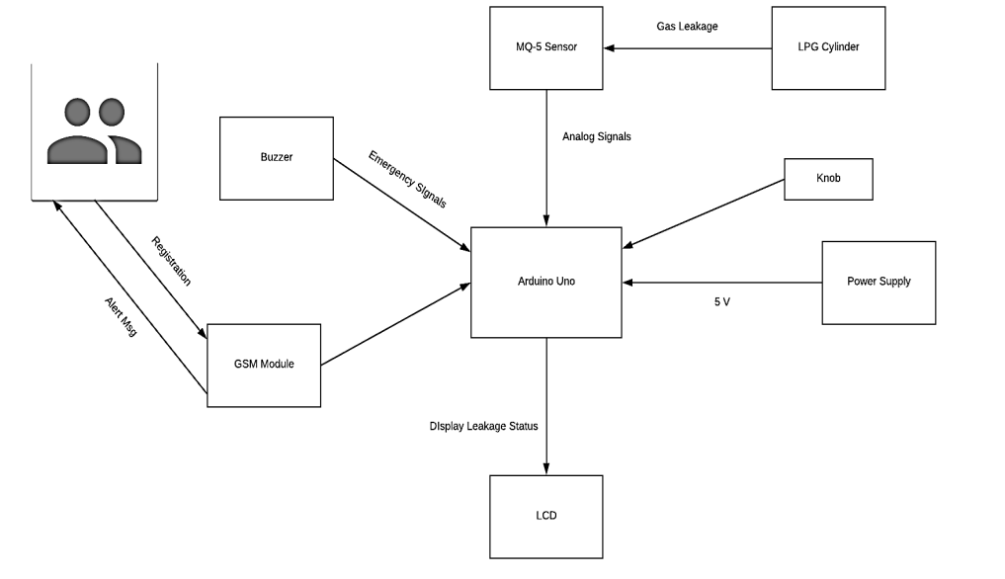

**CONCLUSION:**

The advantage of this simple gas leak detector is its simplicity and its ability to warn about the leakage of the LPG gas. This system uses GSM technique to send alert massage to respective person if no one is there in the house and then gas leaks occurs, GSM module is there to send immediate messages to the respective person regarding the gas leak . The main advantage of this system is that it turns off the regulator knob of the cylinder automatically when gas leakage is detected.

**REFERENCE**:

1.Internet of Things (IOT) Based Gas Leakage Monitoring and Alerting System with MQ-2 Sensor by Rohan Chandra Pandey , Manish Verma , Lumesh Kumar Sahu.

2.GAS LEAKAGE DETECTION AND SMART ALERTING SYSTEM USING IOT by Shital Imade, Priyanka Rajmanes, Aishwarya Gavali , Prof. V. N. Nayakwadi.

3.Gas Leakage Detection and Alert System using IoT by Sayali Joshi, Shital Munjal, Prof. Uma B. Karanje.

4. Kumar Keshamoni and Sabbani Hemanth. "Smart Gas Level Monitoring, Booking & Gas Leakage Detector over IoT " International Advance Computing Conference IEEE, 2017.

5. Asmita Varma, Prabhakar S, Kayalvizhi Jayavel. “Gas Leakage Detection and Smart Alerting and Prediction Using IoT." Internet of Things and Applications (IOTA), International Conference on. IEEE, 2017.